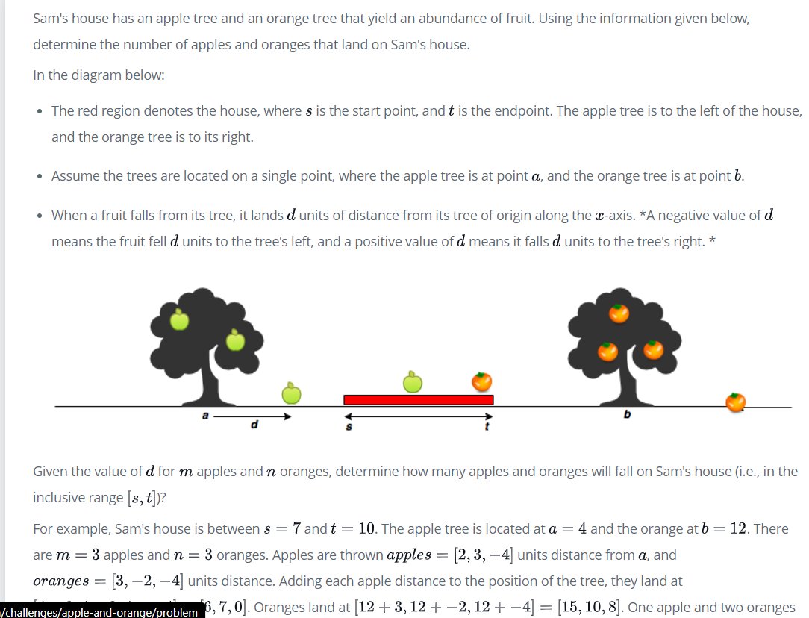

My Approach:

final_apples=[]

    final_oranges=[]

    count1=0

    count2=0

**for** i **in** **range**(0,**len**(apples)):

        final_apples.append(apples[i]+a)

**for** i **in** **range**(0,**len**(oranges)):

        final_oranges.append(oranges[i]+b)

**for** i **in** final_apples:

**if** i>=s **and** i<=t:

            count1+=1

**for** i **in** final_oranges:

**if** i>=s **and** i<=t:

            count2+=1

**print**(count1)

**print**(count2)

Simple way:

print(sum([1 for x in apple if (x + a) >= s and (x + a) <= t]))

print(sum([1 for x in orange if (x + b) >= s and (x + b) <= t]))